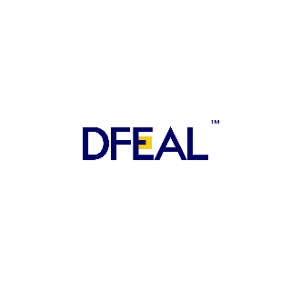  CAPABILITY STATEMENT  "Delivering Compliant, Agile Solutions for Mission-Critical Healthcare Programs"  ABOUT US  We are a healthcare and program management consulting firm providing specialized support to mission-critical organizations through healthcare program coordination, clinical and research administration, operational support services, and medical supply procurement.  CORE CAPABILITIES  Healthcare Program Management Support  We provide end-to-end program and project coordination, PMO support services, and healthcare operations management. Our team drives deliverable and milestone tracking, stakeholder engagement, risk and compliance tracking, process improvement initiatives, and administrative and operational support.  Clinical & Research Support Services  We support clinical trial coordination, research operations, and regulatory documentation management. Services include SOP development and document control, data collection and quality review, study tracking and reporting, IRB and compliance support, and clinical operations administration.  Government Medical Supply Procurement  We source and procure PPE, hospital consumables, clinical and laboratory supplies, mobility and patient support equipment, and monitoring accessories. We manage vendor sourcing, supply coordination, and emergency preparedness support for government and healthcare clients.  DIFFERENTIATORS  INTEGRATED SERVICE MODEL Research, program mgmt & procurement through one relationship  REGULATORY FLUENCY Deep FDA & IRB compliance expertise  CLINICAL CREDIBILITY Leadership grounded in ICU, research ops & healthcare mgmt  AGILE DELIVERY PMP-certified with Lean Six Sigma & Agile/Scrum execution  TECHNOLOGY & TOOLS  Epic Cerner MS Project Smartsheet SharePoint Salesforce  PAST PERFORMANCE  Client Scope  Holy Cross Health Healthcare program coordination & clinical research administration  Adventist HealthCare PMO operations & grant/contract administration  Johns Hopkins Medicine IRB coordination, regulatory documentation & clinical trial support  Encompass Health Operational support/ Program Management  Phison Gate LLC Consulting / Program Management  STAKK A LLC Consulting / Program Management | CERTIFICATIONS & QUALIFICATIONS  PMP® Project Management Professional (PMP)®  CSM® Certified ScrumMaster (CSM)®  LSS Lean Six Sigma®  CDIS Clinical Documentation Improvement Specialist (CDIS) ®  RN Registered Nurses (RN)  BUSINESS DESIGNATIONS  Designation Small Business (SB)  SAM.gov Registered & Active  UEI G1XCPA2ANMC3  CAGE 15RT3  NAICS CODES  NAICS Codes 541611, 541618, 541714, 541512, 561320, 423450  CONTACT  Contact Olatunde, Business Development Lead  Phone +1 (844) 442-0529  Email info@dfeal.com  Web www.dfeal.com  Address 254 Chapman Rd, Ste 208, Newark, DE 19702

